B & B, Inc. Notes – Week of October 17, 2016
Curriculum Notes:
ELA: Students will focus on point of view, perspective, and purpose in literary texts and how it shapes content, meaning, and style.

Reading homework is due on Thursday. Two hours of reading at home. Complete the Padlet by 7:45 a.m. on Thursday. Read and answer all questions on the Padlet.

SS: We are continuing our Westward Expansion unit. This week, we will focus on how the transcontinental railroad impacted the development of the West. We will also identify examples of conflict and cooperation between occupational and ethnic groups in the West, such as, miners, farmers, ranchers, cowboys, Mexican and African Americans, and European and Asian immigrants.

Math: The students will continue their learning of 1 digit divisors in the beginning of the week. They will continue to use the traditional method to solve division word problems and will then move into solving 2 digit divisor long division. They will have great resources in Schoology for practice.

Math Homework: Students will be given a paper copy of math homework Monday night. The homework will be due on Wednesday.

Science: Students will continue the Ecosystem unit. They will spend the beginning of the week completing their own food chain using google drawings and then will share their food chain in class to explain the passing of energy through various consumers. We will end the week learning about the similarities and differences between food chains and food webs.
Mark Your Calendars:
- Oct. 19 – Pastries for Pastors (7:15 – 7:45 a.m.)
- Oct. 20 – Fall pictures $ due
- Oct. 21 – Teacher Workday – No School
- Oct. 24 – Report Cards & Health Screening
- Oct. 28 – Clemson / USC reading forms due
- Nov. 8 – Election Day – No School
- Nov. 10 – Veterans Day Program @ 9:30 a.m.

Congratulations to our Students of the Week
Logan & Caleb
Congratulations to our Mathematicians of the Week
Theoshja & Kellen

Thank you B & B, Inc. families for supporting Read-a-thon.
Students – Don’t forget to log your reading online.
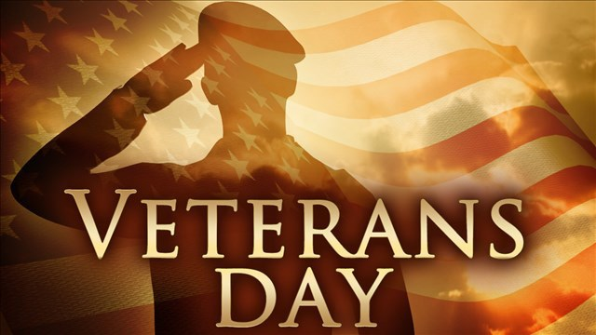
BSIS Red Ribbon Week “I Elect To Be Drug Free” 10/17/16-10/20/16
Monday I Elect to be Drug Free- Wear as much red, white, and blue as you can!
Tuesday Crazy Sock Day in Support of Socktober
Wednesday Don’t Be Bullied Into Drugs- Wear your orange to show your support for Unity Day and National Bully Prevention Day!
Thursday Team Up Against Drugs- Wear your favorite sports team gear!

BSIS Veterans Day Program
November 10, 2016 @ 9:30 a.m. in BSIS gymnasium
Families and veterans are welcome to attend.
Socktober
Join the BSIS Beta Club as they collect socks for The Haven, a homeless shelter in Spartanburg. Students can donate new adult and children’s socks. Socktober will run from October 3 – 20. Help us “kick it to poverty”!
 |  |  | Parent Signature
Monday | L I G H T
Tuesday | L I G H T
Wednesday | L I G H T
Thursday | L I G H T
Friday | L I G H T |  | No School

